**Factorial of a Number**

**What is the factorial of a number?**

* Factorial of a non-negative integer is the multiplication of all positive integers smaller than or equal to n. For example factorial of 6 is 6*5*4*3*2*1 which is 720.
* A factorial is represented by a number and a  ” ! ”  mark at the end. It is widely used in permutations and combinations to calculate the total possible outcomes. A French mathematician Christian Kramp firstly used the exclamation.

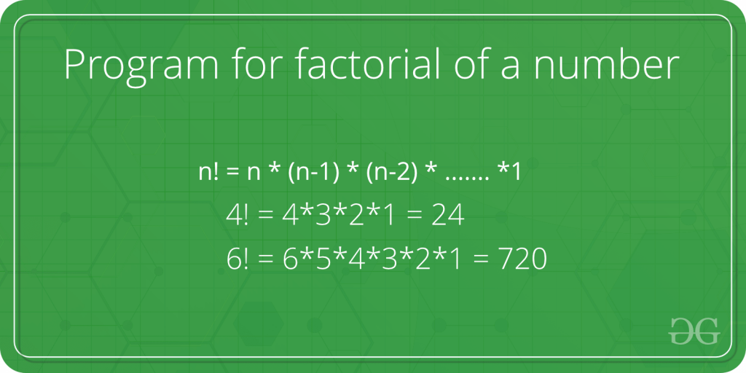

Let’s create a factorial program using recursive functions. Until the value is not equal to zero, the recursive function will call itself. Factorial can be calculated using the following recursive formula.

*n! = n * (n – 1)!*  
*n == 1 if n = 0 or n = 1*

Below is the implementation:

C++Java

// C++ program to find

// factorial of given number

#include <iostream>

using namespace std;

// Function to find factorial

// of given number

unsigned int factorial(unsigned int n)

{

if (n == 0 || n == 1)

return 1;

return n * factorial(n - 1);

}

// Driver code

int main()

{

int num = 5;

cout << "Factorial of "

<< num << " is " << factorial(num) << endl;

return 0;

}

**Output**

Factorial of 5 is 120

**Time Complexity:**O(n)  
**Auxiliary Space:** O(n)

**Iterative Solution to find factorial of a number:**

Factorial can also be calculated iteratively as recursion can be costly for large numbers. Here we have shown the iterative approach using both for and while loops.

**Approach 1:**Using For loop

Follow the steps to solve the problem:

* Using a for loop, we will write a program for finding the factorial of a number.
* An integer variable with a value of 1 will be used in the program.
* With each iteration, the value will increase by 1 until it equals the value entered by the user.
* The factorial of the number entered by the user will be the final value in the fact variable.

Below is the implementation for the above approach:

C++Java

// C++ program for factorial of a number

#include <iostream>

using namespace std;

// function to find factorial of given number

unsigned int factorial(unsigned int n)

{

int res = 1, i;

for (i = 2; i <= n; i++)

res *= i;

return res;

}

// Driver code

int main()

{

int num = 5;

cout << "Factorial of "

<< num << " is "

<< factorial(num) << endl;

return 0;

}

**Output**

Factorial of 5 is 120

**Time Complexity:**O(n)  
**Auxiliary Space:** O(1)